Machine Description | A deliberately vulnerable lab machine for practicing web app exploits, privilege escalation, and post-exploitation to gain user and root access.
Target IP | 192.168.0.152
Vulnerability Name | Weak Passwords & Privilege Escalation (Bruteforce Login + Insecure Script)
Port / Service | TCP 80 / http
Severity | 8.1 high
Attack Vetor | CVSS:3.0/AV:L/AC:H/PR:N/UI:N/S:C/C:H/I:H/A:H
Proof of Concept (PoC) | STEP 1 – Nmap to find the IP of the target machine.  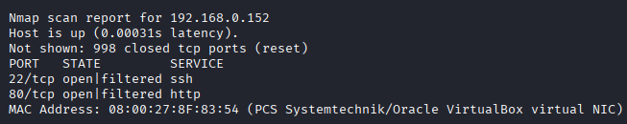  STEP 2 – Nmap Scan to discover open ports and Services  # nmap –p- -sC –sV $ip –open  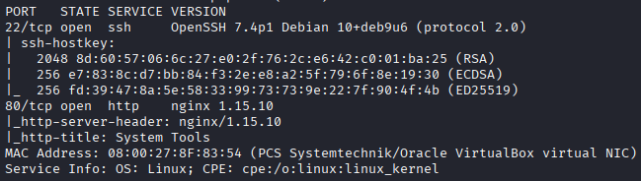  Step 3 – Found a login page  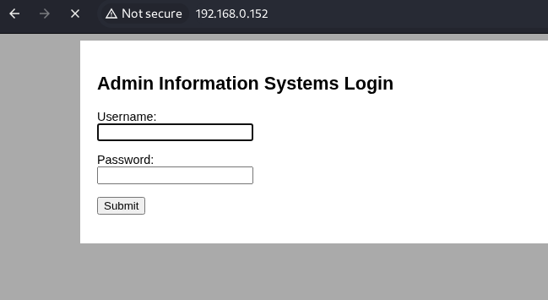  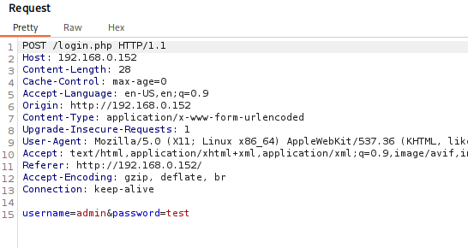  Step 4 – Captured the packet using burp suite  Step 5 – Right-click and send back it to intruder  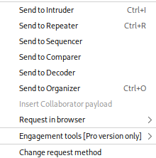  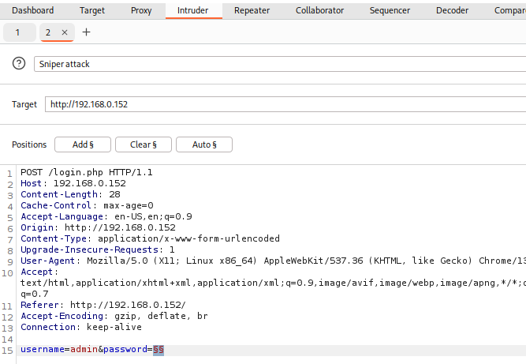  Step 6 – We will brute force it using rockyou.txt through Burpsuite, go in Intruder tab and remove the password and click on add.  Step 7 – Now we’ll load the rockyou.txt, click on load the select the rockyou-20.txt  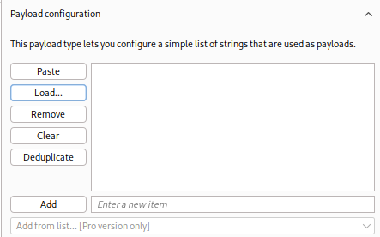  Step 8 – It will take sometime to load it  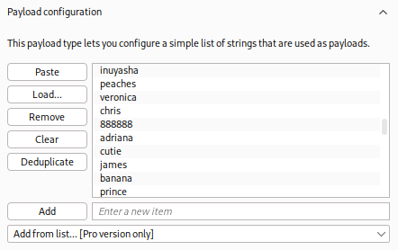  Step 9 – Click on Start Attack to start.  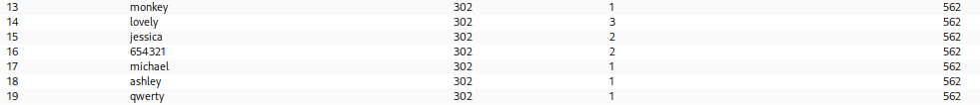  Step 10 – We will find the password by seeing the response size, the correct happy attempt with have different response size, the password is happy  Step 11 – We are in  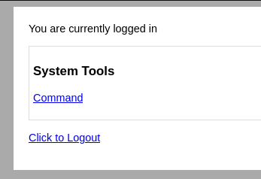  Step 12 – We can execute system level command  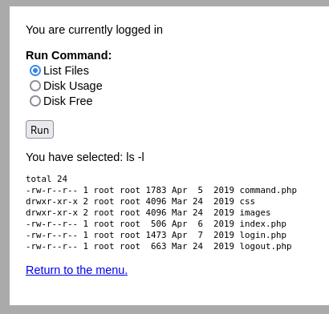  Step 13 – Got reverse shell using burp suite on netcat  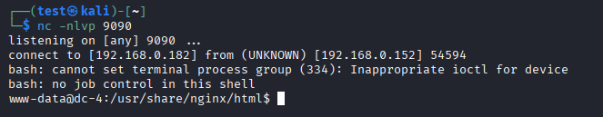  Step 14 – Found old passwords in a file  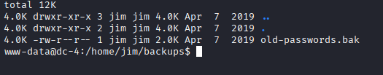  Step 15 - Used hydra to brute force using the old passwords and found a valid user.  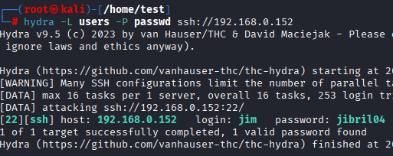  Step 16 – Found passwords for Charles: ^xHhA&hvim0y  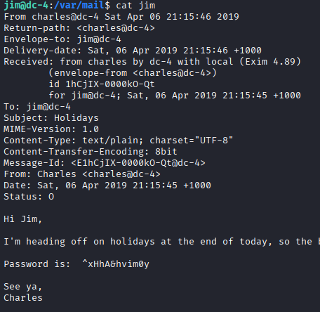  Step 17 – Found a exploitable script  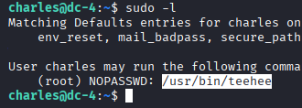  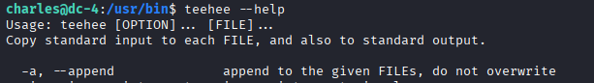  Step 18 – We can use it to append the /etc/passwd file  Step 19 –  Step 20 – We are root now  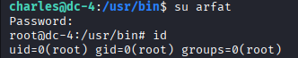  PROOF:  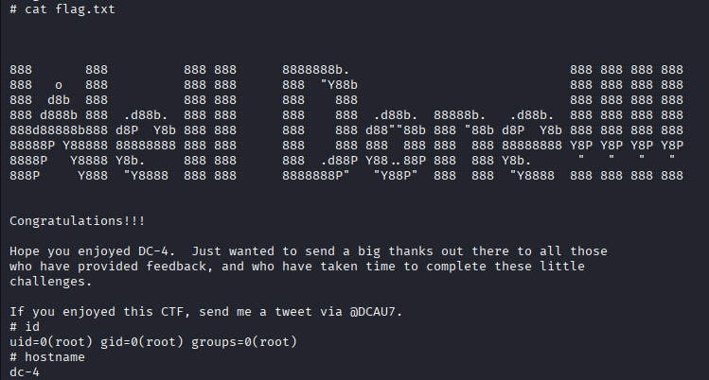
Remediation | • Use strong passwords and enable account lockout  • Remove plaintext/old passwords  • Fix/remove insecure script and restrict file permissions  • Keep system updated
Impact | Attacker can log in, run system commands, access user accounts, and escalate to root, gaining full control of the machine.
References | https://owasp.org/www-community/attacks/Weak_passwords  https://owasp.org/www-community/Broken_Access_Control  https://www.ncsc.gov.uk/collection/passwords

